
Year 7

Investigation 2018

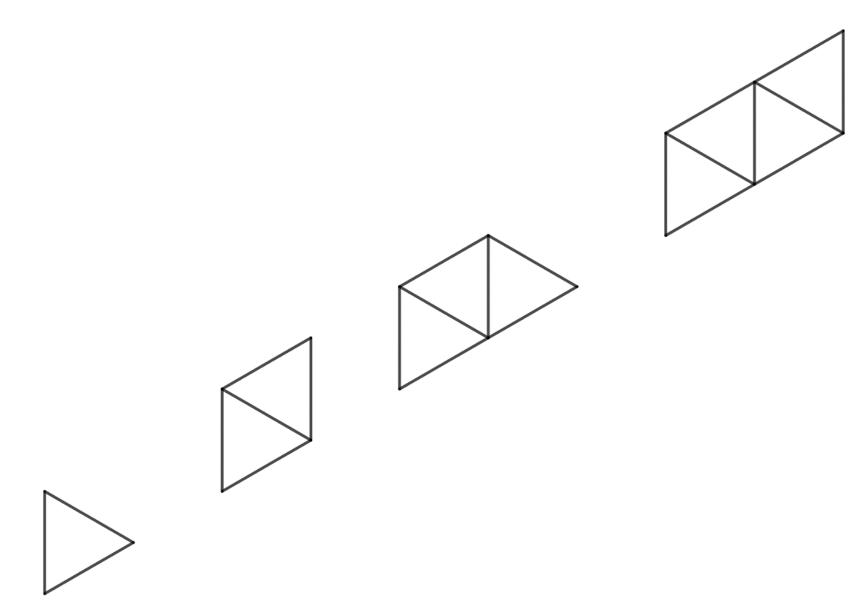
Number and Algebra
Total Marks: 36 marks

Name: ______________________ Teacher:____________________ Mark:________________

Section Two - In- Class validation
Question 1
(13 marks)

1 2 3 4

- Draw the shape number 5 for the pattern above.

- Complete the table below for the patterns above.

Shape number (n) | 1 | 2 | 3 | 4 | 5 | 6
Perimeter of the shape (P) | 3 |  | 5

- Describe any pattern that you can see in the table.

- What is the perimeter for shape number 9?

- Write a sentence describing the relationship between the shape number and the perimeter?

- Let n be the shape number and P be the area of shape. Write a rule using symbols and letters between the shape number and area.

- Using your rule, what is the perimeter of shape number 25. (Show your working)

- If the perimeter of a shape is 110, what is the shape number?(Show your working)

Question 2
(11 marks)

1 2 3 4

- If the pattern above was made using matchsticks. Complete the table showing the number of matchsticks for each shape.

Shape number (n) | 1 | 2 | 3 | 4 | 5 | 6
Number of matchsticks(m) | 3 | 5

- Describe any pattern that you can see in the table.

- Write a sentence describing the relationship between the shape number and the perimeter?

- Let n be the shape number and m be the number of matchsticks. Write a rule using symbols and letters between the shape number and area.

- Using your rule, how many matchsticks are needed for shape number 22. (Show your working)

- If I have 55 matchsticks, what is the shape number? (Show your working)

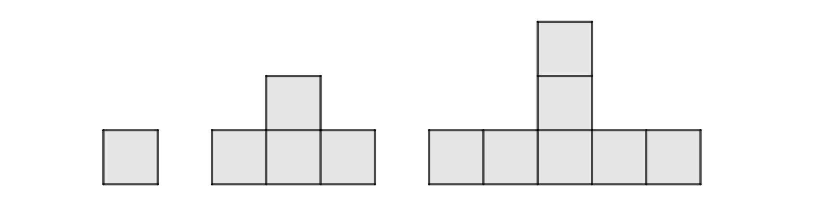
Question 3
(12 marks)

1 2 3

Investigate the above shape pattern.
Design a table
Make some predictions.
Make a generalisation in your own words.
Write down the rule.
Show how your rule works.

End of Investigation

